Grade 7 Vocabulary
Week 2: Worksheet 2
Directions: After reading an article on weather and the environment. Sam wanted write his own article to share with other. Some of the words are missing out. Help him fill them in.
Flooding is when water rises above normal levels for a period of time. Flooding serves both positive and _______________ (urban, adverse, outage) purposes. Flooding can be cause by poor _______________ (drainage, agriculture, sewage), especially in __________________ (infrastructure, devastation, urban) areas where overcrowding is an issue. When it floods, _______________ (infrastructure, sewage, submerge) can be forced into homes and buildings, leading to ____________________ (devastation, electrocute, adverse). This is unhealthy and dangerous. The ___________________ (submerge, outage, infrastructure) of an entire city can be damaged causing a power _______________ (outage, electrocute, submerge). This leaves inhabitants vulnerable. However, some flooding is used for _____________________ (urban, agriculture, waterlogging) to help soil and improve the ___________________ (ecosystem, devastation, monsoon). This is used during __________________ (electrocute, submerge, monsoon) season. A farmer will block drains so a field can _________________ (sewage, outage, submerge) and be nourished by the water. This allows crops to grow later in the year.
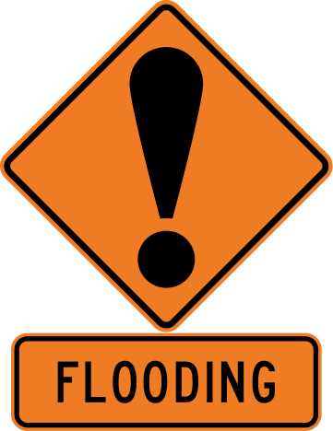

Answer Key

Worksheet 2
adverse
drainage
urban
sewage
devastation
infrastructure
outage
agricultural
ecosystem
monsoon
submerge

